Word Sorts
*Ways to Sort*
(Partner = a grown up)

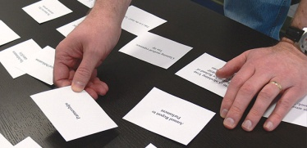
Open Sort:
Cut words. Put your headers away. Sort your words/pictures in any way by any feature/pattern. Explain
to your partner how you sorted.

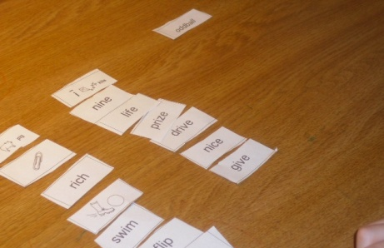
Basic Closed Sort:
Lay out and sort your words by the headers. Read aloud the words and explain to your partner why they are sorted in a particular way.

Blind Sort:
Lay out the headers. Have a partner call out your words while you point to the category in which they belong (you have to hear and not see the words).

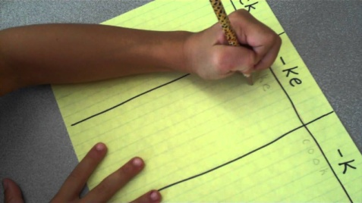
Writing Sort:
Write out your headers on scrap paper. Read and write words in the correct category.

Speed Sort:
Sort your words as fast as you can. Repeat 2-3 more times. Try to be faster!

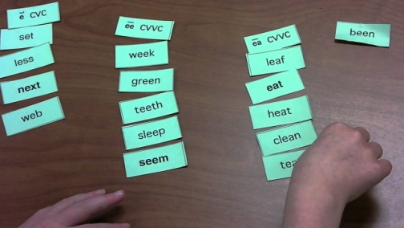

Word Detective
Look for words with your pattern in books, poems, newspapers, etc. Write them on a scrap paper.

Paste Sort:
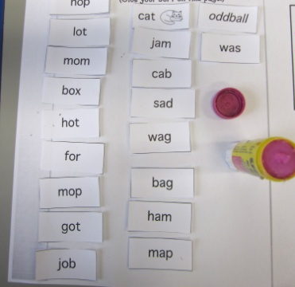
Sort your words or pictures on scrap paper. Have your partner check. Glue down & display proudly.
Other Ideas

- Thursday– Students may participate in any of the following spelling games/activities:

Taboo- Students work with a partner to play this game. One student places a word card on their forehead while the other student gives them clues to identify the word. They are not able to say rhyming words. Students are encouraged to use the meaning of the word. When the student guesses correctly they say and spell the word. Once all words are completed, roles are reversed.

Word Hunt- Students look for words in books that fit the rule/pattern. Words are recorded in their Word Study notebook.

Concentration- Students work with a partner to play this game. Students use one set of words and lay them face down. Cards are flipped over two at a time. The student is to read the words and determine if they belong in the same category. If the words belong in the same category, the student has found a match and keeps the words. This continues with students taking turns until all words have been used.

